Assignments on Exception Handling

1) Write an application that accepts two numbers, divides the first number with the second

number and display the result. Hint: You need to handle ArithmeticException which is

thrown when there is an attempt to divide a number by zero.

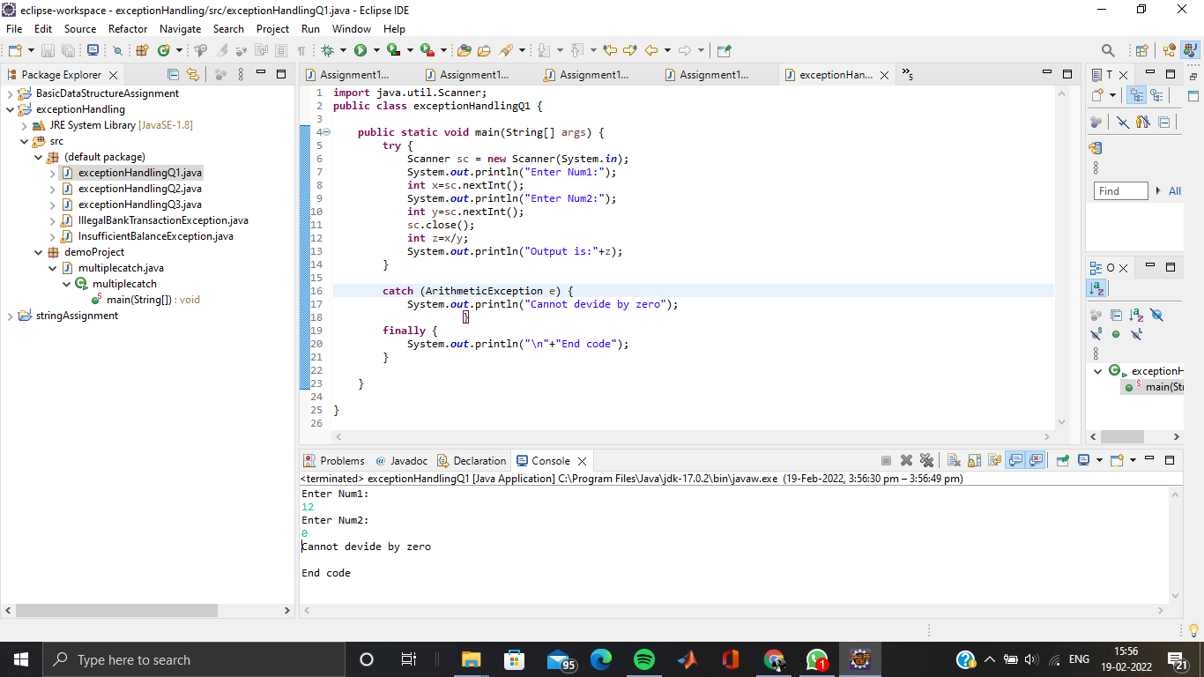

2) Carrying forward with the above problem, handle ArithmeticException by raising

UnsupportedOperationException as a solution.

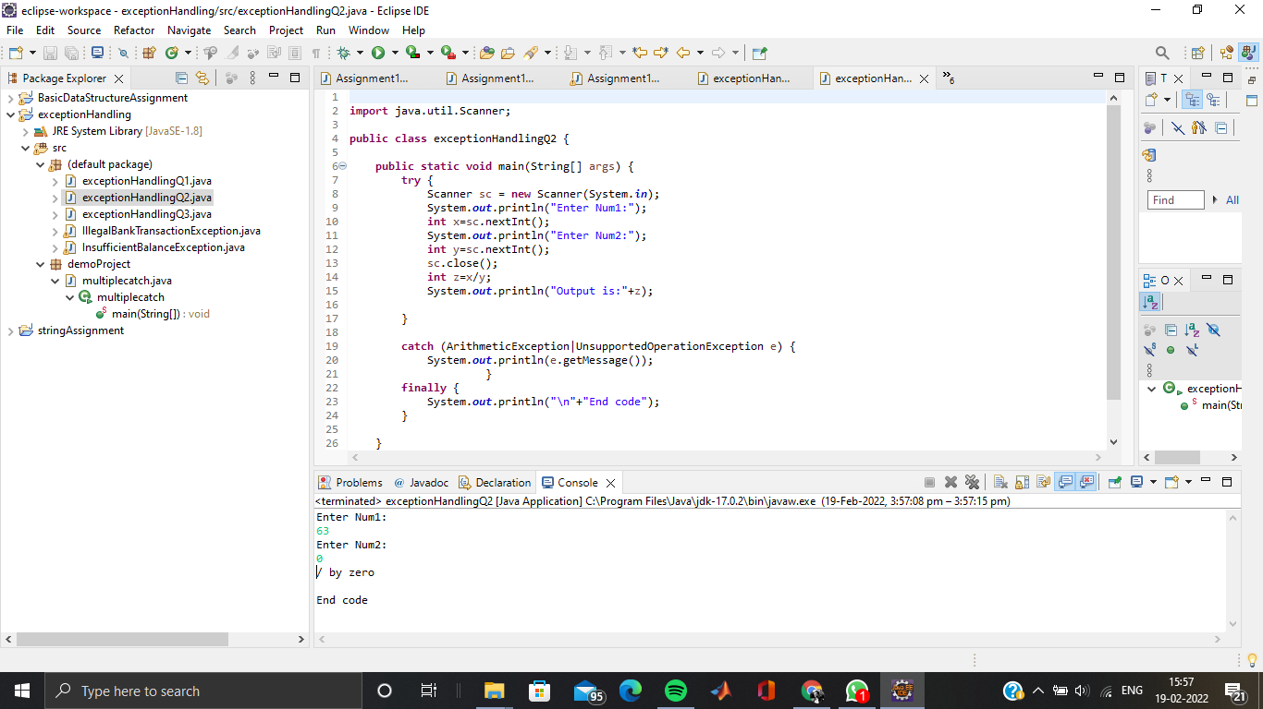

3) Write an application to perform withdraw functionality on a SavingAccount object. Point to

note:

a. Raise InsufficientBalanceException if you are trying to withdraw more than balance

or when you balance is zero. E.g. if you balance is 2000 and if you are trying to

withdraw 2100 or if you balance is 0 and you are trying to withdraw positive value.

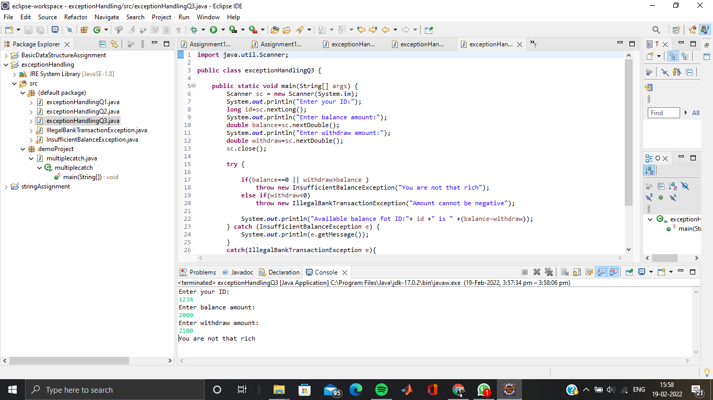

b. Raise IllegalBankTransactionException if you are trying to withdraw a negative value

from your balance. E.g. if you try to withdraw a negative value savingAcc.withdraw(-

1000);

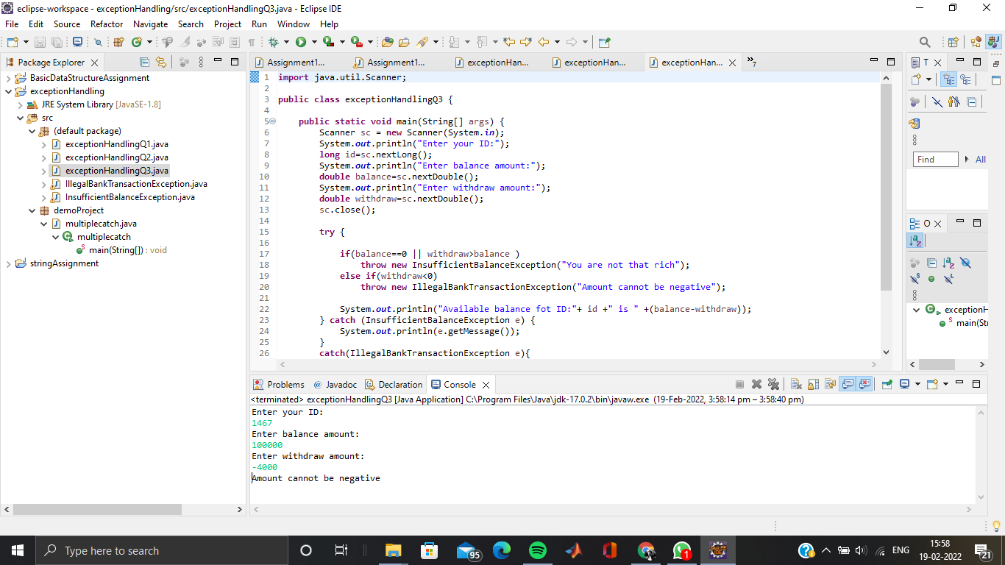

Note: SavingAccount

|-- long id

|-- double balance

|--double withdraw(double amount)

|--double deposit(double amount)